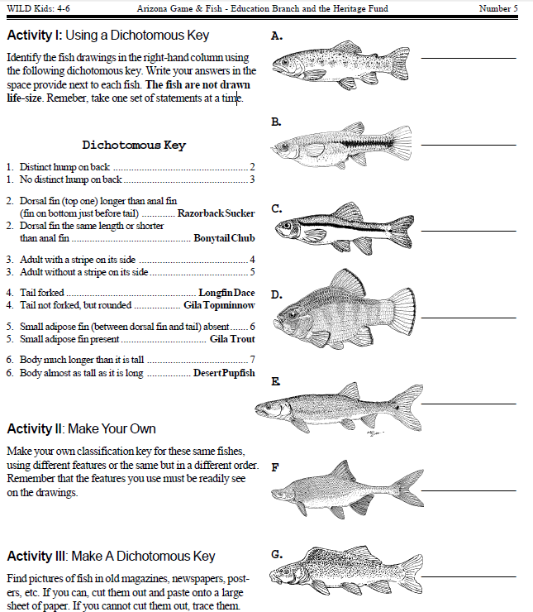

**Unit 10: Classification Dichotomous Key Name________________**

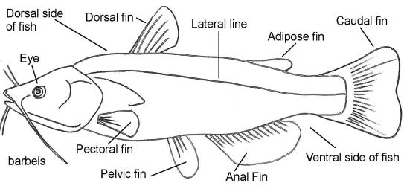

**Unit 10: Classification Dichotomous Key Name________________**

